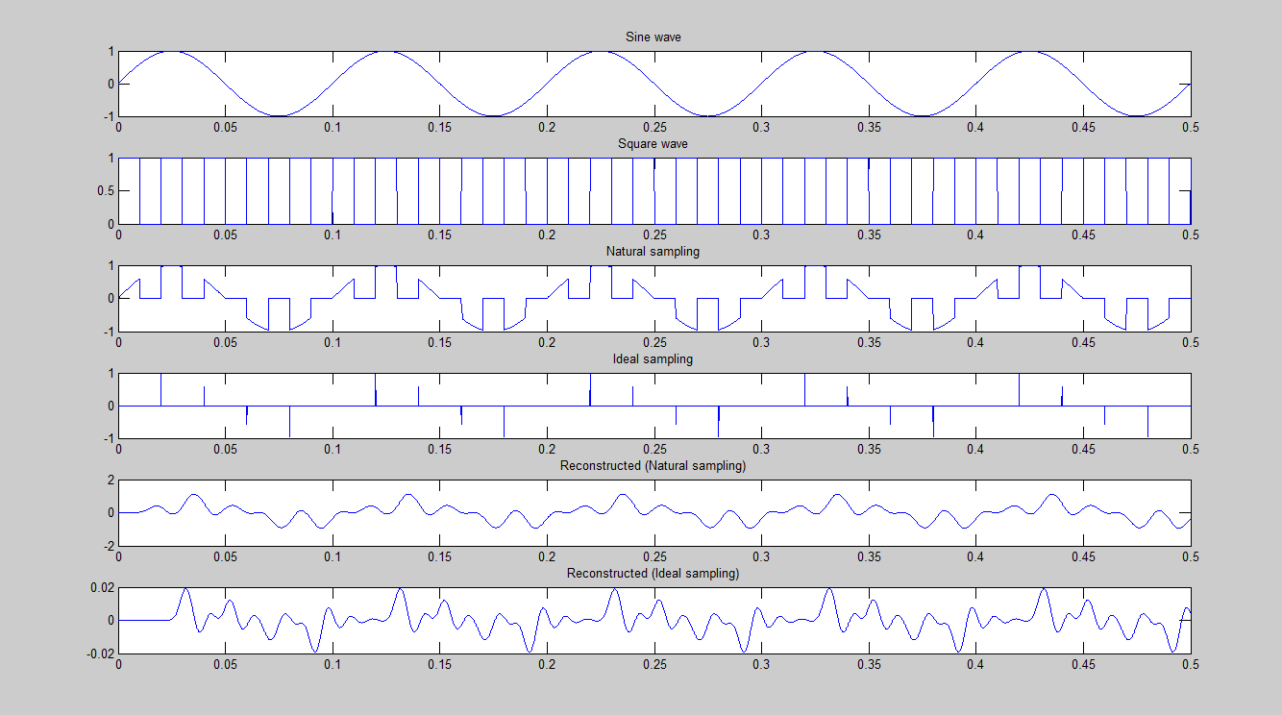
Experiment 1

CODE:
a = input('Enter amp');
fm = input('Enter freq');
t=0:1/(1000*fm):5/fm;
sig = a*sin(2*pi*fm*t);
subplot(6,1,1);
plot(t,sig);
title('Sine wave');
fs = 5*fm;
sq = (1+square(2*pi*fs*t,50))/2;
sqideal = (1+square(2*pi*fs*t,0.1))/2;
subplot(6,1,2);
plot(t,sq);
title('Square wave');
samp = sig.*sq;
subplot(6,1,3);
plot(t,samp);
title('Natural sampling');
sampideal = sig.*sqideal;
subplot(6,1,4);
plot(t,sampideal);
title('Ideal sampling');
[n,d] = butter(10,1/50);
recon = filter(n,d,samp);
subplot(6,1,5);
plot(t,recon);
title('Reconstructed (Natural sampling)');
reconideal = filter(n,d,sampideal);
subplot(6,1,6);
plot(t,reconideal);
title('Reconstructed (Ideal sampling)');

